DRIVE NOW TEXT LATER
PLANNING & IDEA GUIDE

OSAID would also like to recognize all the students and staff advisors in the Province of Ontario who have given countless volunteer hours
by making their schools and communities safer.

WHY DOES YOUR SCHOOL NEED OSAID?
OSAID is a youth run leadership program.

Who better to reduce impaired driving crashes among students than students?

OSAID started in 1987. Since that time the largest decline in the rate of impaired driving has occurred in the youth population.

We have a problem and you have the solutions.

Paying it forward: OSAID Alumni. OSAID has graduated ten’s of thousands of student leaders who are now living, working and driving throughout Ontario. If each of these leaders educated only 50 of their peers about the dangers of impaired driving, then we have reached millions of people with a safe and responsible message.

You don’t need to have a big group some OSAID groups have five members, while others have fifty members. One person can make a difference.

STARFISH STORY
Once upon a time, there was a wise man that used to go to the ocean to walk on the beach. When he looked down the beach, he saw a person. As he got closer, he saw that it was a young man who was reaching down to the shore, picking something up and very gently throwing it into the ocean.
As he got closer, he called out, “Good morning! What are you doing?” The young man paused, looked up and replied, “Throwing starfish in the ocean”.
“I guess I should have asked why you are throwing starfish into the ocean.”
“The sun is up and the tide is going out. If I don’t throw them in they will die”.
Designed by snowing / Freepik
“But young man, don’t you realize there are miles and miles of beach and starfish all along it? You can’t possibly make a difference.”
The young man listened politely, then bent down, picked up another starfish and threw it into the sea. “It made a difference to that one!”

STUDENT QUOTES:
Why did I get involved with OSAID?

“I was interested in starting an OSAID chapter to give students at my school an opportunity to get involved, lead peers, gain confidence, and make a difference. I wanted to offer something to students from a variety of backgrounds, with a variety of interests and strengths. Also, I guess the
fact that I grew up with an alcoholic mother factors into the equation as well, but honestly, it was more about the students and making people both inside and outside of our school more aware of the MANY dangers associated with impaired driving.

“Students join OSAID for different reasons. I joined for the wrong ones. I joined because I hated an impaired driver and a sort of thought that would give me revenge. I learned through the amazing people I met and the experiences we shared it should be about educating and stopping someone from making the wrong decisions.”

“I honestly didn’t even know how big of a problem drinking and driving was until I went to the OSAID Provincial conference! It was an exceptional experience, and it changed me completely! I’ve gotten into cars where my
friends had a few drinks just before driving, I never realized how dangerous and life threatening it is. Our school isn’t very active and we never had an OSAID chapter until after the conference. I got back and spoke to our principle and began the chapter with just one other friend, it slowly grew to 5 of us, which isn’t a lot but they were a big help! I am not the outgoing type who speaks in front of large groups but OSAID never hold yourself back from anything, if you want to do it go for it!”

“My sister was the leader of our chapter and she urged me to come out to a meeting, I went and immediately realized it was the place for me. It was a group of strong kids trying to make a difference on a topic that affected our generation. I knew I wanted to help spread awareness and help stop drinking and driving.”

Share your story story https://www.osaid.ca/submit-your-story

Any school can start their own chapter. All you need is the motivation to make your school and community safer. Your OSAID chapter may be small, it is important to remember that there are OSAID chapters all over the province of Ontario. You are not alone. Together, we all form a powerful force for positive change!

Form a Core Group
You have a tremendous amount of strength. Get a bunch of people together (friends, other students) - and form a core working group. OSAID is all about youth engagement.

You need Principal/School Support
Part of a school principal’s job is to support the student body. If you explain to your principal:
- why you want to start an OSAID chapter
- who will benefit (the student body, & community
- what’s involved (time/staff/personal commitment)
Approaching them openly and honestly will establish a good working relationship, which will benefit you in the future: They can help with;
- feedback on events/ideas
- Guidance about school rules/regulations

You need a Staff Advisor
Ontario Students Against Impaired Driving believes in peers educating peers. But here’s how the staff advisor fits in.
You support the students. The staff advisor supports you.
- in order to be an “official” organization/club within a school you need a staff advisor
- any contracts/agreements you may need for supplies, resources, to hold an event, will need the signature of an adult
- Adult experience/knowledge will serve you well with problem solving, working with your community and the school office.
Adults can prove to be quite valuable if you let them!
Remember: If you ask a teacher to be your staff advisor and they say “no”. Don’t take it personally. That teacher may have a many other things to do and will know if they have the time to help you. It is better to have a staff advisor who has the time to help you with your group.
Some schools may not have a teacher to act as a staff advisor. You may want to explore other options available to you. For example - a.) Local Public Health Nurse who is working in the schools on various youth issues, or alcohol awareness projects may be willing to act as your advisor. b.) Parents may be the advisor. - Ask your principal if they could approach the School’s “Parent/School Council” to ask if one of the members would like to be a volunteer staff advisor.

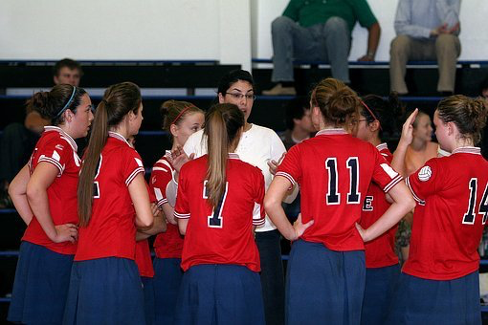

The Positive Comments

- “My Staff Advisor listen to us, lets us run with ideas and then gives us a reality check. Without them our meeting would be way off track and we would never get anything done”
- “My Staff Advisor let’s us plan everything, which sound great but it is ten times more work.
- “Sometimes what would take us a couple days to figure out can be done by our advisor with one phone call.”
- “…our staff advisor was appointed to run the OSAID group and you can tell they really don’t want to be part of it so we asked if the local health nurse (who has helped us with events ) could attend a couple of meetings as a guest. –Now the health nurse attends most of the meetings and it gives our teacher more time do other things. –Everybody is happy.
- “If not for our Staff Advisor we would not be allowed to go to the OSAID conference”

Recruiting OSAID Members
Why do sports teams try to recruit the best players? They want to improve their position, achieve their goals, make things happen and ultimately be a success. For the same reasons you need to recruit a solid team to back you.
The type of members to look for:
- motivated, supportive, committed
- variety of ages, grades, interests, talents
- personal relation to the cause
- energy
- resourceful, having the means and the methods (student council rep., staff advisor(s), leaders)

How to Recruit Members:
- generate some interest
- word of mouth
- have current members bring their friends
- be direct - “we need you”
- look around you - enlist people you interact with on a regular basis
- offer incentives - give them something for their efforts – pizza
- give them responsibility/sense of ownership - people like a challenge, assign them a small specific task
- emphasize personal achievement - sense of accomplishment/confidence

Recruiting Your Peers
“There’s no better way to educate your peers then to include them”

Spread the Word - Impaired Driving Awareness
- plan an awareness campaign
- build anticipation over time - plan small events that lead up to your main event
- organize an assembly – invite speakers
- hold lunchtime fun events like the Tricycle Race, with drunk busters goggles
- ask creative people to create posters
- set up information tables near the cafeteria
- create posters, P.A. announcements

Keep your school in the loop - keep them informed
- place articles/updates in school newspapers, newsletters, websites, club section
- set up a bulletin board/central information area to post updates
- use P.A. and class announcements

Time to put your chapter in motion.
TIME TO CALL THE FIRST MEETING

Make the meeting an informal one.
- get to know each other -Ask everyone to say their “name and their favourite movie” – it is an easy ice-breaker
- acknowledge each others support “Thanks for coming”
- talk about the goals and objectives of OSAID -ask people “Why are you here?” -it helps to see who may have been affected by impaired driving.
- discuss general goals your chapter would like to achieve
- lay out responsibilities that will need to be filled “President, secretary etc.”
- give yourselves ideas/events/etc to think about
- have fun
- But most importantly make sure everybody who attends the meeting was given the chance to participate. If they feel like they are needed then they will want to come back to the next meeting.

Give everybody little research tasks that are easy to do. Ask everyone to bring their findings to the next meeting.
Tasks such as:
- Check out the OSAID website www.osaid.ca and choose what school awareness event you can put on at your school. Have each member pick one event they think would be fun/good/ exciting to do at the school.
- Contact the OSAID student regional representative for your area (see www.osaid.ca) and introduce yourself and chapter by e-mail.
- Find out when and where the next OSAID workshop is being held in your area by checking www.osaid.ca
- Find out when, where the OSAID Provincial Conference is being held and plan on sending at least two members to this conference.

Establish and assign responsibilities so everyone knows what they are to do.

If you are going to create the traditional roles of “President and Vice President” it usually follows that the President is in Grade 11 or 12. If this is the case please try to make sure the Vice President is
in grade 10 so when you graduate there is a new president in place who you have groomed for the job.

- Think of campaign/event ideas. Brainstorm
- Decide on your campaign/events.
- Then figure out how to make it happen!
ADMINISTRATION

AKA (also-known-as) THE OFFICE
To start OSAID or any club within your school, you must have approval from your Principal.
If your group decides to do an event (with staff advisor approval), the next step is to go to:
The Vice-Principal (or Principal) in charge of activities and/or events at your school
Your Administration (the office, - Principal, Vice Principal, and office Staff) can be your best friends.

School Assemblies:
There are many speakers on the issue of impaired driving.
E-mail info@osaid.ca for recommendations.
Remember: Your administration can be your best supporters - don’t count them out.

MEETINGS
It is important that your meetings are interesting and structured. People like leaving meetings with a feeling of accomplishment. This can be achieved by creating an agenda and appointing a chairperson and secretary.
- Make sure everyone knows the time, date and place of each meeting. Try to be consistent. For example, meetings held at 3:00 every second Wednesday.

Get the locker numbers and text numbers of everybody in your group and appoint someone to slide a meeting reminder note in each locker or group text.
- Make an agenda. If you feel like being really organized you could put the date of the meeting on the agenda and circulate it to your members prior to the meeting. Text everyone the day before the meeting, the morning of the meeting and 10 minutes before the meeting begins.

OSAID MEETING
MONDAY, JAN. 10 12:15 in Rm. 212

AGENDA
  - Final details on assembly 10 min.
  - Poster campaign: 15 min.
design contest, production costs, distribution
  - OSAID Mock-tails at a dance 5 min.
sign-up helpers
  - T-Shirts 10 min.
  - New Business 5 min.

- Stick to your agenda and keep the discussions on track. It is the job of the chairperson to direct the meeting and keep it on track.
- Have a secretary record the minutes of the meeting. Minutes are just a snap shot of what was said at the meeting.
The “MINUTES” of the meeting should really only reflect the tasks that need to be done. “Action Items”

For example:
“Motion to hold an assembly on December 10th. –All in favour.
Kaitln agreed to look into possible speakers to do the presentation, costs, etc.
Mr. Staff advisor will check with the principal to see if the administration will allow us to do an assembly.

The minutes of the meeting can look as simple as this:

Task | Who to do | Completed by?
Vote on Assembly Date | All in Favor | Done
Find a speaker | Kaitlen | Next Meeting
Get OK from Principal | Mr. Staff Advisor | Next Meting

If the meeting is really well organized, people will leave with a great feeling of accomplishment. Keep it interesting and constructive.
If people miss a meeting, inform them about what they missed.
It really helps if the secretary makes copies of the minutes and gives them to members at the next meeting. This is a big job, but someone will enjoy doing it. ASK!
If people feel that they are not participating, they will slowly lose interest in the group.

The Chairperson of a meeting is like a traffic cop.
- Their main job is to get everyone to talk about each topic (an item) on the agenda. (But make sure everyone does not talk at once.)
- Then they have to take everything that was said about the topic and turn it into one sentence (a motion) that everybody can vote on. They can also ask people to create a motion about the item.
For example:
- Let’s say one of the items on the agenda is T-Shirts (getting t-shirts for all the OSAID members.)
- You realize that a little word like T-Shirts has a lot of discussion around it such as; What colour, how much, what will it cost, does each person pay or do we have a fundraiser to pay for them, somebody’s mother owns a T-shirt store, etc……

You could go on forever and everybody has their own opinion.

Group member: “This one, time, at summer camp, we had these t-shirt, and my cousin, took this can of shaving cream, and bla, bla, bla, ”

So the chairperson has the job of saying:
Chair person: “OK, hold on!!!! Let’s organize these ideas “Would someone like to make a motion to get T-shirts for the OSAID group?”
Group Member: “I would like to make a motion that we get T-shirts for the group and pay for them by doing a fundraiser”

Everybody votes –Majority rules
But now you have opened the discussion to a bunch of new related topics or motions.
Such as: “I would make a motion to appoint Katlin (who’s mother owns a T-shirt store) to see what it would cost to make T-shirts and report to us at the next meeting”
“I would like to make a motion to find a volunteer to design a logo for the group”
“I would like to make a motion to create a sub-committee (2-4 people from you group) to look into possible fundraisers we can do and report at the next meeting so we can vote on which one to do”

OSAID Public relations is about how you are perceived by your peers, your teachers and people in you community.

School - students, peers, teachers
Community - parents, media

PUBLICITY in your school
- The best publicity in schools is word-of-mouth.
- Don’t assume students listen to announcements.
- Be classroom specific; i.e. French language posters in French classrooms.
- Cover all areas of the school. Don’t forget the cafeteria or school hang outs.
- Don’t assume people read posters, mass e-mails or group chats.
- Use every means possible to advertise your event. – Be creative

PUBLICITY outside the school (community)
- Create a Media List (social media, radio, local weekly-newspapers, TV-cable stations newsletters)
- Media people love “NEW” that is why it is called “news”, Try to make your event appear to be NEW, never done before, exclusive, like no other, not to be missed!
- Talk to local media people; ask one to act as a mentor for your group.
- Newspapers love local news. Don’t be scared to do this. It is just an e-mail away.

What is your goal?

The goal of OSAID is to reduce and eliminate impaired driving. Your objective is to make your group fun interesting and effective.

SET SPECIFIC GOALS
Take ideas from your list generated at your brainstorming session. Oh – you haven’t had a brainstorming session? Well, have one Use the ideas which are workable. Think in terms of the entire year – don’t just think from event to event. By setting a year goal plan you will get a clear vision of what you need and how much time you need to achieve that goal.

GIVE EACH GOAL A DEADLINE
You must set dates and time frames. Give yourself deadlines. Stick as close to these deadlines as you possibly can.

MAKE A LIST OF MATERIALS YOU’LL NEED
Your event/activity may include handing out pamphlets, giving away key chains or finding buckets and sponges for a car wash. Make a list of the materials you need and when you need them. Make sure that your group has these materials before the date of your event.

FIND OUT WHAT RESOURCES YOU WILL NEED
When planning your event, consider how many people you need to make it a success. Take time to plan how much money, if any, your group will need to purchase materials for the event.

SETTING TASK RESPONSIBILITY
Create a list of all the tasks needed to prepare for the event. Do not miss any tasks like “Clean- up Crew”. Once you have created a list of tasks to be done ask for volunteers to be responsible for certain tasks. Ask others who have specific talents to help out, i.e. artists for posters.
If there are tasks left unclaimed, ask if anyone in the group knows of others, outside your chapter who could help. Remember, recruitment is ongoing – by getting people involved at one event, they may become interested and join the chapter.

Getting Feedback
It is important to know if you are making an impact with the events you plan. With your goal in mind, figure out a way to monitor whether your event was successful.

This could be done by merely looking at the attendance and attitude of the crowd, or by designing a questionnaire; i.e. Did you like the event? How could it be improved? Do you have any additional ideas to help us with future events?

ACTIVITY NAME: Guest Speaker DATE OF ACTIVITY: November 25

Action Person Responsible | Date to be completed | People, Money, Resources Needed | Materials/Equipment
STEP 1  Book assembly Richard  (speak with principal) | October 6
STEP 2.  Research topic James  Book speaker | October 15 | 1 person
STEP 3  Posters Julie, Kris, Max  (Announcements) | October 17 | 3 people | Paint, paper, tape
STEP 4  Audio set up Contact AV head Wendy, Matt  Etc…. | November 25 | 2 people | Podium, video, projector, speakers, music

ACTIVITY NAME:________________________________ DATE OF ACTIVITY:________________________________

Action Person Responsible | Date to be completed | People, Money, Resources Needed | Materials/Equipment

(Photocopy this page)

There are OSAID campaign/events that come and go every year. All of them support your efforts to stop impaired driving. Working them into your OSAID year is a definite plus.
Here’s a look at some of the OSAID campaigns / events:

September | October | December | February | April | May | June
BYOB  Bring Your Own Banana | National Students Against Impaired Driving Day  Car Wash | School Assembly | Candy Grams | Arrive Alive Sober Suds Car wash | OSAID  Provincial Conference | Safe Grad

REGIONAL WORKSHOPS & LEADERSHIP CONFERENCE
Workshops are organized and hosted by OSAID throughout the year. They allow OSAID chapters within a region to get together and
  - discuss issues around impaired driving
  - give chapter event/activity updates
  - share resources and ideas
  - Hear new speakers
  - Create region wide activities
  - Connect with local resources like Public Health
www.osaid.ca

OSAID Provincial Conference
Ontario Students Against Impaired Driving hosts a Provincial Conference for all students, teachers and community supporters involved with the fight against impaired driving in May.

Days are filled with:  - motivational speakers  - leadership building  - workshops  - brainstorming  - campaign/fundraising strategies  - booths, displays, information overdrive  - peer interaction  - OSAID regional rep elections | Nights are filled with:  - performances  - activities  - meeting new people  - social events  - show

Available OSAID resources Info@osaid.ca

Most resources are available from the OSAID office or on the website
- Posters & Promotions
- Drunk Driving Googles ( loan only -two weeks per school)
- Student Regional Representatives - on hand to answer your questions and help your group.

EVENT IDEAS
Shock value doesn’t mean scare. Create an unforgettable experience!

Events
- wrecked car
- floor decals
- spontaneous announcements

Plan an awareness campaign
- build anticipation over time - plan small events that lead up to your main event
- organize an assembly - invite speakers (Public Health, Police, etc)
- create message oriented skits, music, visual art
- set up information tables in school
- hand out quizzes, games; set up challenges
- create posters, pamphlets, P.A. announcements

Keep them in the loop - keep them informed
- place articles/updates in school newspapers
- set up a bulletin board/central information area to post updates
- use P.A. and class announcements maintain interest level
- attach a message to existing mailings (i.e. school newsletter that goes to parents)

Wrecked Car:

EVENTS TO RUN AT YOUR SCHOOL !!!

Parking a “wrecked” car outside your school will definitely send out a message!
- Contact a local towing company - tell them about OSAID and your idea, ask if they would be willing to provide a wrecked car (towing & all for free).
- Choose a good place for the car
- set the scene - go one step further and create a collision scene, ask for help from your local Public Health Unit, OPP, local Police
- bring in the media - invite local media to cover your activity

The Chain of Life:

Everyone is a link in the chain of life.
- get students to write their names with permanent marker on a strip of paper
- make a link chain
- hang your chain somewhere in the school students will see it

Candle Light Vigil
The gathering of people to light a candle for those that have been victims of impaired driving crashes.
Some schools have included someone reading a poem or, someone singing the song, and of course, the lighting of candles and a moment of silence. This touching event makes you realize that impaired driving effects everyone, both young and old.

Parade Float
Put an OSAID float in a community parade.

Liquor Bag Campaign
Contact a LCBO store in your community and ask if they would be interested in a partnership for this fantastic event. They supply you with brown paper liquor bags and then you take them to elementary schools (grades 1-5) and have the children draw or put phrases on why they think drinking and driving is so bad. Then return to the local LCBO.

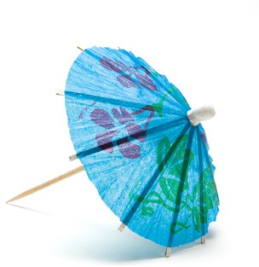
Mocktails
Make non-alcoholic drinks and give them away to students at lunchtime or at a dance. Mocktails are easy to make.

Whiteout Day
Every 30 minutes or so there is an impaired driving crash in Ontario. To give students and staff a visual idea of these OSAID members will “white people out”.
You start in the school office randomly picking names from a student list. Then every 30 minutes through- out the day OSAID students go to the students class and “white them out” by painting their face white and putting a sign around their neck saying the time they were killed by the impaired driver.

Body Outlines
OSAID students place body outlines on the floor throughout the school using masking tape.
OSAID chapters then put a poster in the outline with the OSAID logo on it. Be sure to talk to your custodial staff at your school, and be sure to remove all of the masking tape at the end of the day.

Coffin/Body Bag Display
Have displayed a few days before graduation. Place a mirror in the coffin so people will be looking at themselves. Use the message “This Could Be You! Don’t Drink and Drive!”

Sucker/Lifesaver
Pass out suckers with the messages, “Don’t be a sucker - Don’t Drink and Drive” or lifesavers with the message, “Be a Lifesaver... Don’t Drink and Drive.”

Grade Nine (or grade 8) Presentations
Grade nine presentations are a great way to:
- introduce OSAID to new students
- inform them what OSAID does at school and in the community
- tell them about the dangers of impaired driving
- invite new members into your chapter

Poster Challenge
- invite peers to create a Drinking & Driving awareness poster
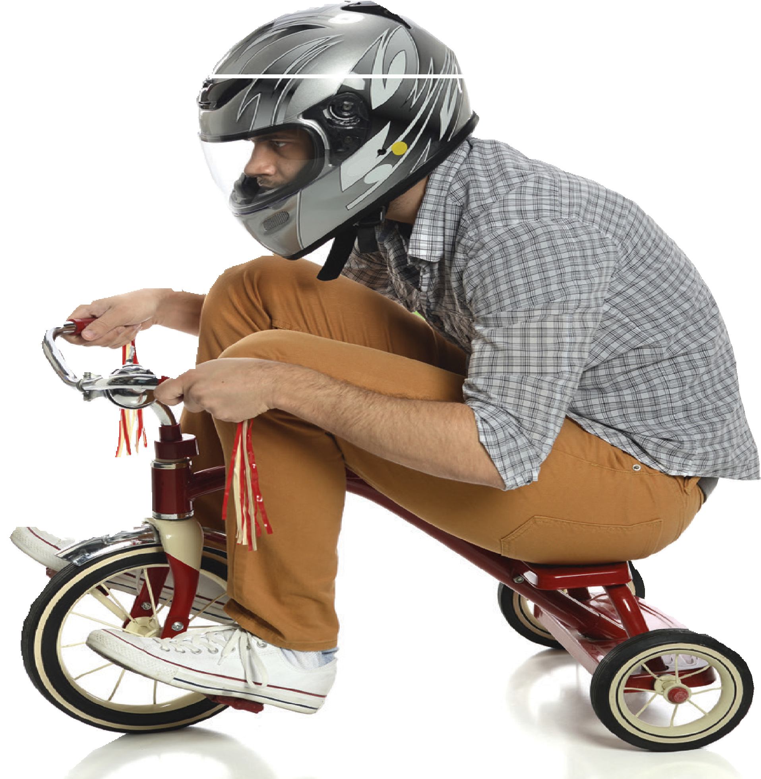
- announce there will be prizes for the top entries (seek donations )
- tie the contest to a class assignment, get your art teachers involved

Drink Driving Goggles & Obstacle Course
An interactive way to test driving skills and raise impaired driving awareness.
- Pick your location - parking lot, school gym, shopping mall...
- set up your course: two tricycles, Fatal Vision Goggles, tape/rope, pylon, vaseline/mactac (clear tape) to impair vision, impaired driver sign, prizes, pit stop signs (Party, Home, R.I.D.E. ) volunteers
(announcer, Police, Student Council. )
- run your course - allow participants to do the course with and without Fatal Vision Goggles, have them stopped
by R.I.D.E., provide Drinking & Driving facts, make it an experience
- Contact OSAID about borrowing the goggles.

BYOB (Bring Your Own Banana)

Who doesn’t love a banana split?!
BYOB promotes fun and the fact that you don’t need alcohol to have a good time!
- arrange with the school cafeteria to hold your BYOB, and possibly use their utensils
- Buy your toppings - ice cream, sauces, whipped cream, nuts, cherries, sparkles...
- Gather your utensils - scoops, spoons, bowls, napkins...
- Set your table
- let in the crowds - they supply the banana and donation, and you provide the rest

School Assemblies
There are many types of school assemblies and speakers. Ask these questions before you book a speaker.
What are you trying to do by holding an assembly?
Scare the student? Shock the students? Make them think?
Make them Cry? Recruit members?
Gain the respect of the school for your cause? Motivate the students?
The OSAID Conference and OSAID workshops are an excellent place to see presenters.

Sober Suds-Car Wash
This is a province wide campaign with a proven track record. OSAID provides a package of materials to help you.
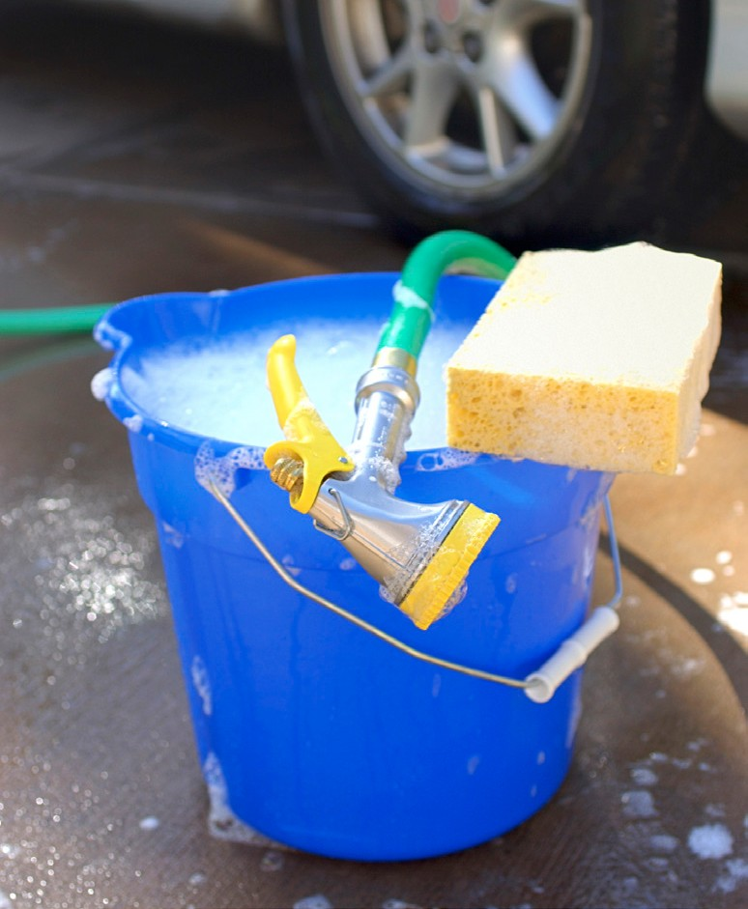
- pick a location - make it visible, accessible, near to water hose outlet and drainage
- pick a time - high traffic time, time of year suitable for washing cars
- Get your stuff together - you’ll need pails, sponges, hoses, clothes, soap, squeegees. (Best if the soap is
environmentally friendly and non-abrasive.)
- direct the traffic - make large readable signs that will lead the cars to you, put up posters around the neighborhood
- greet the cars - say a friendly hello, provide information as to why you are holding Sober Suds and ask if they would consider making a donation

COMMUNITY RESOURCES

Public Health Nurses
OSAID’s best friend
Public Health Units Across Ontario
Many of the health units in Ontario are interested in working with OSAID groups to help them with events or campaigns. They can be an amazing help to you.
- Call the main line and ask for the name of the nurse in charge of “youth substance abuse issues” and specifically “impaired driving issues”
- Tell them you are OSAID representative at your school and you are just touching base to let them know that you have an OSAID group at the school and perhaps they would like to stay in touch throughout the year.

Police Services
Police Services Across Ontario
Many of the Police services in Ontario are very interested in working with and supporting OSAID groups with events or campaigns. They can be an amazing help to you.

How do I get in contact with my local police services?
Check out your local phone-book for your OPP or local Police Services
- Call the main line and ask for the name of the “Community Services Office” In charge of your school.
- Tell them you are the OSAID representative at your school and you would like to speak them about your OSAID group at the school.
- Once you have made contact keep their name and number or e-mail on file.

Remember: By being part of OSAID you are helping to make your community safer and helping teens to be more responsible and you should express this reality to anyone you are approaching for sponsorship.

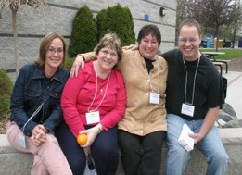

Each year there are two scholarships available for OSAID students across the Province for work achieved in the issue of reducing impaired driving.
OSAID Scholarship 2 X $500
SCHOLARSHIPS

To apply for these scholarships you must submit a package to OSAID Inc. based on the following criteria.
Send your package to: INFO@OSAID.CA

Criteria for scholarships
These scholarships are available to all graduating OSAID members in Ontario and will be judged by a committee consisting of non-OSAID Inc. Board members.

Education:
- Must be enrolled in at least 3 full time secondary school courses
- Must be in their final year of secondary school
- Must have a letter from the school principal stating they are a recognized student at the institution and a member of the school’s OSAID group.

School participation in OSAID
- Must be a recognized leader of the OSAID Chapter.
- Must have helped organize at least two school-wide campaigns/events.

Community Support
1. Must have helped organize at least one community-wide campaign.

Support letters
Must enclose one support letter from each of the following:
- Secondary School teacher advisor
- Community member
(Public Health Nurse, Chaplain, Mayor, Reeve, Councilor, MP, MPP, Police Force, boss etc.)

Additional Requirements
* Each participant must compose a one page detailed biography of their work in the anti-impaired driving issue.
*Each participant may also include newspaper clippings, news interviews, and photos involving their participation in the anti-impaired driving issue.

Presentation of scholarships will take place at the OSAID annual conference.

