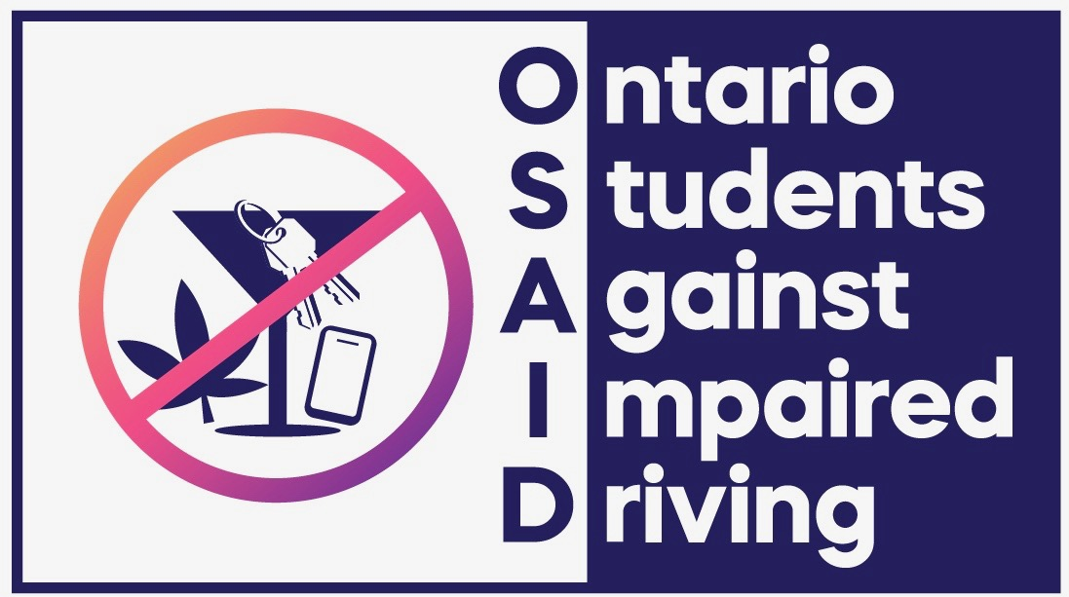
Principal Permission Form 2026/27
OSAID: Safe Roads Grant Application
The OSAID: Safe Roads Grant provides $500 in funding to student groups who wish to raise awareness and run educational activities addressing the dangers of impaired driving.
To apply for this grant, each student group must obtain written confirmation from their school principal, confirming support for the project.
School Information
- School Name: _______________________________________________________
- School Address: _____________________________________________________
- Principal’s Name: ___________________________________________________

Student Group Information
- Name of Student Group (e.g., OSAID, Student Council, etc.):_______________________
- Lead Teacher Contact Person: _____________________________________________
- Project Title: OSAID: Safe Roads Grant
Principal’s Permission
I, the undersigned, hereby grant permission for the above student group to apply for and, if successful, receive funding through the OSAID: Safe Roads Grant. I support the implementation of impaired driving awareness-raising education and activities at our school.
I understand that the funds awarded will be used exclusively for this purpose and that the school will provide general oversight of the student-led initiative.

Principal’s Signature: _______________________________
Date: _____________________________________________

Principal’s Email: __________________________________
Principal’s Phone: __________________________________

